**Resume**

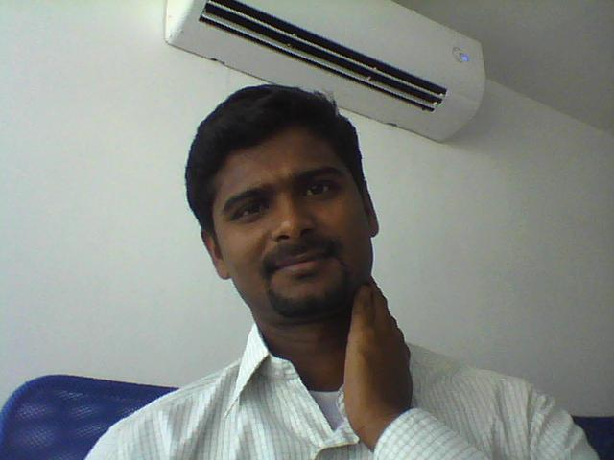

**P.PRABHU PANDIAN**

**Assistant Sports Officer,**

**IIT Bombay, Mumbai India.**

**E-mail:** [**prabhubala22@gmail.com**](mailto:prabhubala22@gmail.com)

**Cell: +918291208968**

**Game of Specialization : Cricket, Tennis & Track and Field**

**Date of Birth : 21 October 1984**

**Working Experience**

1. ***Two years*** of working experience as a ***Physical Education teacher* in *Thamarai International School*, Thanjavur (July 2009 – 16 May 2011)**
2. Worked as Physical Education Teacher cum Cricket Coach in **KOOH Sports** PVT.LTD November 23, 2011 - March 31, 2016.
3. Working as **Assistant Sports Officer** in Indian Institute of technology Bombay (**IIT Bombay**) from April 12, 2016 – till date

## Achievements in KOOH Sports

* KOOH **coach of the Year** 2012 – 2013
* Travelled to **Australia** (Brisbane) for seven days Athletics coaching camp.
* Recently promoted as a **Level – 3 coach** in KOOH sports

## Educational Qualifications

|  |  |  |  |  |  |  |  |
| --- | --- | --- | --- | --- | --- | --- | --- |
| **Degree/ Diploma/ Cert. Awarded** | **Name of the Institution** | **Name of the University/ Board** | **Major Subjects** | **Year of Passing** | **% of Marks** | | **Class/ Division** |
| **B.Sc.,**  **(PHS)** | **ANJAC Sivakasi** | **Madurai Kamarajar University** | **Physical Education** | **2002-05** | **77.45%** | | **First Class**  **DISTINCTION** |
| **B. P. Ed.,** | **Alagappa University Karaikudi** | **Alagappa University Karaikudi** | **Physical Education** | **2005-06** | **74%** | | **First Class** |
| **M. P. Ed.,** | **Dr SACPE Tiruchendur** | **TNPESU**  **Chennai** | **Physical Education** | **2006-08** | **78.45%** | **First Class**  **DISTINCTION** | |
| **M.Phil.,** | **M S university Tirunelveli** | **M S university Tirunelveli** | **Physical Education** | **2008-09** | **84%** | **First Class**  **DISTINCTION** | |
| **Ph.D.,** | **TNPES**  **University**  **Chennai** | **TNPES**  **University**  **Chennai** | **Physical Education** | **2016** | | | |

**Title of the Thesis**

**M. Phil : “Effect of Music on Heart rate Sweat rate and Breath rate”**

**Ph.D : Effect of with and without music on selected physiological and psychological variables among obese students**

**Seminars, Conferences and Workshop Attended & Paper Presented**

# State Level

1. **Participated in the State Level Workshop on “Volleyball, Handball, and Athletics” Organized by Dr. Sivanthi Aditanar College of Education, Tiruchendur on April 2009.**
2. **Participated in the State Level Workshop on “basketball, Kho-kho, and Athletics” Organized by Dr. Sivanthi Aditanar College of Education, Tiruchendur on April 2008.**

**National Level**

1. **Participated in the UGC Sponsored National Conference on Physical Education, Sports and the Art of Well- Being and presented a paper entitled “Effect of Stick Drill Training on Speed Parameters” Organized by the Department of Physical Education, Bishop Heber College, Tiruchirappalli on 20th March 2009.**
2. **Participated in the UGC Sponsored National Conference on Role of Sports Sciences and Technology in Enhancing Sports Performance and presented a paper entitled “Enhancement of Flexibility and Balance by Stability Ball Training” Organized by the Department of Physical Education, Bharathidasan University, Tiruchirappalli on 21st March 2009.**

**GAMES KNOWN**

**\* Cricket**

**\* Tennis**

**\*Basketball**

**\*Volleyball**

**\* Football**

**\*Swimming**

**\*Throwball**

**\*Yoga**

**\*Swimming**

**Tamil Nadu State Officials**

1. **State Technical Official in Throwball, Recognized by Tamilnadu throwball associationAthletic Association 2007.**
2. **State Technical Official in Kabaddi, Recognized by Tamilnadu Kabaddi Association 2008.**

**Achievement in Games / Athletics**

1. **Member of the Alagappa University Cricket Team, in the 2005-2006 tournament held at Manglore.**
2. **Member of the Dr. SACPE Cricket Team, which was the Runners-up in the TNPES University Inter Collegiate Zone Tournaments in 2007.**
3. **Member of the Dr. SACPE Ball Badminton Team, which was the Runners in TNPES University Inter Collegiate Zone Tournaments in 2008.**

**Roles and Responsibilities of Coach/PE Teacher/Sports Officer**

* To educate players through communicating ideas and concepts
* To improve players technical ability by applying knowledge and skills
* Promote fair play and laws of the game
* Gain trust of players, parents and fellow employees
* Establish and outline realistic goals and objectives
* Continually learn
* Delivering and controlling sessions in an organised, effective and, most importantly, safe manner

## Provide Maximum Physical Activity Time With in the Class Period.

## Teach Skills and Activities That Transfer Into Physical Activity Outside of Physical Education Class.

## Motivate Children to Be Active

* Valuating and monitoring activities and projects using performance indicators;
* Maintaining records and producing written report

**DECLARATION**

**I hereby declare that all the statements made above and information given in this profile is true to the best of my knowledge and belief**

**P.Prabhu Pandian**